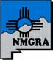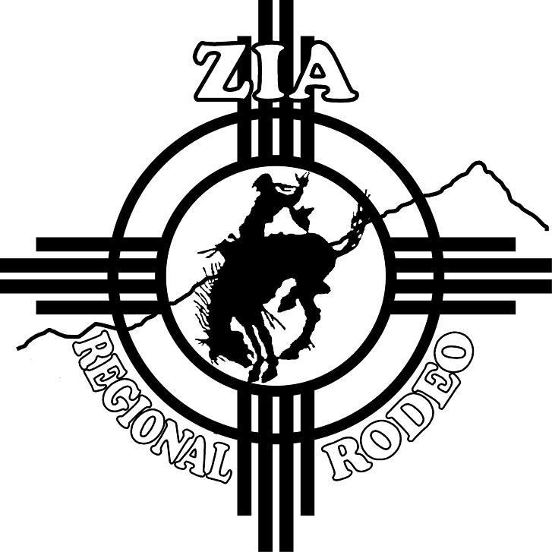

New Mexico Gay Rodeo Association
PO Box 15537

Rio Rancho, NM 87174

